Department of Computer Science and Engineering
The University of Texas at Arlington
Sliding Profiler
Architecture Design Specification

The Builders Group Ltd.

Team Members:
Chudamani Aryal
Lloyd Bond
Tyler Buchanan
Jefferson White
Late Updated: d MMMM yyyy 41162.7291666667 h:mm:ss am/pm
Copy Printed: d MMMM yyyy 41152.9861111111 h:mm:ss am/pm

Table of Contents
1 Sliding Profiler 3
1.1 Document Overview 3
1.2 Product Scope and Overview 3
1.3 Project Architecture Concepts 3
1.4 Project Architecture Scope 3
2 Meta Architecture Overview 4
2.1 Overview 4
2.2 Vision 4
2.3 Guiding Principles 4
2.4 Assumptions and Tradeoffs 4
3 Input Layer 5
3.1 Overview 5
3.2 Purpose 5
3.3 Function 5
3.4 Dependencies 5
3.5 Interfaces 5
3.6 Processing 5
3.7 Data 5
4 Processing Layer 7
4.1 Overview 7
4.2 Purpose 7
4.3 Function 7
4.4 Dependencies 7
4.5 Interfaces 7
4.6 Processing 7
4.7 Data 7
5 Storage Layer 8
5.1 Overview 8
5.2 Purpose 8
5.3 Function 8
5.4 Dependencies 8
5.5 Interfaces 8
5.6 Processing 8
5.7 Data 8
6 Output Layer 9
6.1 Overview 9
6.2 Purpose 9
6.3 Function 9
6.4 Dependencies 9
6.5 Interfaces 9
6.6 Processing 9
6.7 Data 9
7 GUI Layer 10
7.1 Overview 10
7.2 Purpose 10
7.3 Function 10
7.4 Dependencies 10
7.5 Interfaces 10
7.6 Processing 10
7.7 Data 10
8 Inter-Subsystem Data Flow 11
8.1 Overview 11
8.2 Data Flow 11
8.3 Producer/Consumer Relationships 11
9 Requirement Mapping 12
10 Input Layer Subsystems 13
10.1 SubsystemA 13
11 Processing Layer Subsystems 14
11.1 SubsystemA 14
12 Storage Layer Subsystems 15
12.1 SubsystemA 15
13 Output Layer Subsystems 16
13.1 SubsystemA 16
14 GUI Layer Subsystems 17
14.1 SubsystemA 17
15 Testing Considerations 18
15.1 General 18
15.2 Physical / Structural 18
15.3 System-level Connectivity Requirements 18
15.4 Subsystem-level Interfaces 18

Sliding Profiler

Document Overview

Product Scope and Overview

Project Architecture Concepts

Project Architecture Scope

Meta Architecture Overview

Overview

Vision

Guiding Principles

Assumptions and Tradeoffs

Assumptions

Tradeoffs

Input Layer

Overview

Purpose

Function

Dependencies

Interfaces

Processing

Data

Processing Layer

Overview
The processing layer provides the function of processing raw data to produce meaningful results. The layer primarily runs the bump detection algorithm.
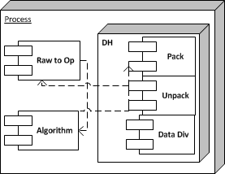

Purpose
The purpose of the processing layer is to process the incoming stream of sensor data in real time, to detect when it indicates a bump, based on the user input configuration that defines a bump. The processing layer shall be the sole component that analyses the sensor data, and the only place that provides bump detection for the system.

Function
The processing layer receives raw sensor data from the input layer, processes it, and sends the processed data (including bump detection information) to both the storage layer and the output layer.

Dependencies
The processing layer depends on the microcontroller to provide processing power. The function of the data processing will be determined by the bump detection algorithm provided by Dr. Walker.

Interfaces
Interlayer interfaces will be handled with the Data Handler subsystem in the processing layer. The processing layer will interface with the other layers as follows:
Source | Destination | Data
Input Layer | Processing Layer | Packaged Raw Sensor Data (Inclinometer, Distance Encoder, Temperature etc.)
Processing Layer | Output Layer | Packaged Processed Data, including bump detection flags
Processing Layer | Storage Layer | Packaged Processed Data, including bump detection flags

Processing
The layer handles processing of raw data, to operational data, to processed data.

Data
The layer takes raw sensor data as input, converts it into operational data, and then using the bump detection algorithm into processed data. This processed data is then sent to the output layer and the storage layer.

Storage Layer

Overview
The storage layer is in charge of keeping and managing both the raw and processed data that the system acquires. It will maintain the physical storage of the data in an order manner, and provide this data on request.
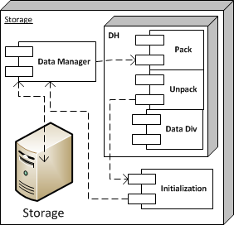

Purpose
The purpose of the storage layer is to provide a means to keep a history of raw and processed data that has been collected by the system so that it can be retrieved later.

Function
The storage layer maintains the physical storage, including initializing the file system. The layer receives live packets of the raw data and processed data, and keeps them on the physical storage. When requested, the storage layer will provide the stored data to the output layer.

Dependencies
The storage layer will depend on some TBD file format to manage the physical storage.

Interfaces
Interlayer interfaces will be handled with the Data Handler subsystem in the storage layer. The storage layer will interface with the other layers as follows:
Source | Destination | Data
Storage Layer | Output Layer | Requested stored data, raw and processed
Processing Layer | Storage Layer | Data processed by bump detection algorithm
Input Layer | Storage Layer | Requests for stored data, also raw sensor data

Processing
The storage layer will process requests for stored data.

Data
The storage layer will keep track of raw sensor data from the input layer and processed data from the processing layer.

Output Layer

Overview
The output layer provides output regarding bump detection to the user. It also controls networking with the GUI layer to provide the raw and processed data as output to the GUI.
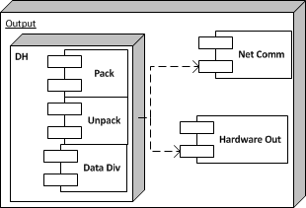

Purpose
The purpose of the output layer is to convey the output of the system to the user. It does this with the lights on the platform (bump detection light and heartbeat in Hardware Out subsystem) and also provides the output to the GUI layer so it can be viewed.

Function
The output layer receives packaged raw and processed data from the input layer and processing layer. It uses the processed data to run the lights on the platform appropriately. It also relays this data to the GUI layer over the network when connected. This data can be both live data and stored data.

Dependencies
The output layer depends on the implementation of the GUI/Platform network to provide a connection to the GUI for output.

Interfaces
Interlayer interfaces will be handled with the Data Handler subsystem in the output layer. The output layer will interface with the other layers as follows:
Source | Destination | Data
Storage Layer | Output Layer | Stored system data (raw and processed) to be sent to GUI
Input Layer | Output Layer | Live raw sensor data
Processing Layer | Output Layer | Live data processed by bump detection algorithm
Output Layer | GUI Layer | System data, raw and processed, live and stored

Processing
The only processing taking place in the output layer is data flow management. The data received in this layer must be passed to either the hardware out or GUI.

Data
The Output Layer receives stored and live system data, including raw sensor data and data processed by the bump detection algorithm. The Output layer sends this data to the GUI layer.

GUI Layer

Overview
The GUI layer is the only layer of the system that runs independently of the physical platform. The GUI layer operates on a PC connected to the system over a network. Both raw and processed data can be displayed and analyzed through the GUI, providing an easy way for the user to check the results. It also allows the user to provide input to configure the device.
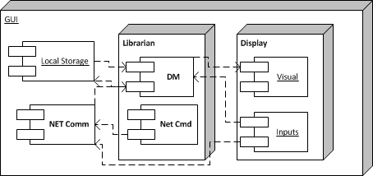

Purpose
The purpose of the GUI layer is to provide an easy to use interface with the user, and display all relevant data from the system in an easy to follow manner. The GUI layer can view live data as it is streamed from the running system, or saved data from the system through either the network or removable storage. The GUI layer also allows the user to configure the device.

Function
The GUI layer is given the data of the system from the Output layer, and stores the data using the PC file system. This data is analyzed and displayed in the GUI to the user. The GUI also has the ability to read data from the Local Storage subsystem that allows for the systems removable storage to be connected. Finally, the GUI also provides the function for the user to configure the system (User Input Configuration) via easy to use GUI inputs.

Dependencies
The GUI layer is dependent on the Windows operating system to provide a storage system to hold data, a run time GUI application and the underlying network capabilities to allow a connection with the system.

Interfaces
Interlayer interfaces will be handled with the Data Handler subsystem in the GUI layer. The GUI layer will interface with the other layers as follows:
Source | Destination | Data
GUI Layer | Input Layer | Requests for stored system data, and User Input Configuration data
Output Layer | GUI Layer | System data, raw and processed, live and stored

Processing
The GUI layer will process incoming system data, store it and display it.

Data
The GUI layer receives system data (raw and processed, live and stored), and sends stored data requests and User Input Configuration Data.

Inter-Subsystem Data Flow

Overview

Data Flow

Producer/Consumer Relationships

Requirement Mapping

Input Layer Subsystems
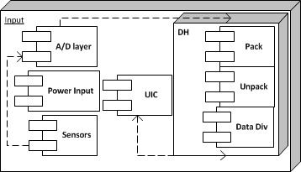

Sensors

General
The sensors of his system include Temperature Sensor, Distance Encoder and Inclinometer. These sensors measure the external world, and provide electrical input to the system.

Assumptions
We assume the sensors measure accurately, and that the temperature and distance inputs are digital and the inclinometer is analog.

Responsibilities
To provide accurate measurements of the environment to the system.

Subsystem Inter-Layer Interfaces
The Sensor subsystem sends all gathered data to the A/D layer.

Subsystem Public Interfaces
N/A

Power Input

General
The power input refers to the control to turn power on to the system. It is an input from the user.

Assumptions
When the power input is turned on, power is supplied to the whole system.

Responsibilities
The power input is responsible for allowing the user to turn on the system.

Subsystem Inter-Layer Interfaces
N/A

Subsystem Public Interfaces
N/A

A/D layer

General
The A/D layer provides the means to change any analog input signals to digital signals that can be used by the system.

Assumptions
The A/D converter used will provide enough resolution to accurately describe the environment for the purposes of the bump detection algorithm.

Responsibilities
The A/D layer is responsible for converting any analog signals to digital signals and passing them forward to the Data Handler. It also passes any other digital signals to the Data Handler.

Subsystem Inter-Layer Interfaces
Raw signals from the Sensors are given as input to the A/D layer as either analog or digital signals. Digital signals of the sensors are output from the A/D layer to the Data Handler.

Subsystem Public Interfaces
N/A

UIC

General
The User Input Configuration (UIC) stores the configuration data on the microchip. It provides a means to hold this data and allow it to be updated.

Assumptions
There will be initial values for the UIC provided before system use.

Responsibilities
To store the UIC data and allow it to be updated.

Subsystem Inter-Layer Interfaces
The UIC gets input from the Data Handler of any updates to be applied to the UIC.

Subsystem Public Interfaces
N/A

Data Handler

General
The Data Handler provides the interface to transfer data to other layers.

Assumptions
All interlayer data flows occur through the Data Handler.

Responsibilities
The Data Handler will be in charge of, packaging data to be sent to other layers, unpacking data received from other layers and dividing the received data to the appropriate subsystem.

Subsystem Inter-Layer Interfaces
The Data Handler receives raw sensor data from the A/D layer, and sends updates to the UIC subsystem.

Subsystem Public Interfaces
The data handler packages and sends the raw sensor data to the Process Layer and the Storage Layer. The Data Handler receives updates to the UIC from the GUI layer.

Processing Layer Subsystems

SubsystemA

General

Assumptions

Responsibilities

Subsystem Inter-Layer Interfaces

Subsystem Public Interfaces

Storage Layer Subsystems

SubsystemA

General

Assumptions

Responsibilities

Subsystem Inter-Layer Interfaces

Subsystem Public Interfaces

Output Layer Subsystems

SubsystemA

General

Assumptions

Responsibilities

Subsystem Inter-Layer Interfaces

Subsystem Public Interfaces

GUI Layer Subsystems

SubsystemA

General

Assumptions

Responsibilities

Subsystem Inter-Layer Interfaces

Subsystem Public Interfaces

Testing Considerations

General

Testing Approach

